**Heuristic Analysis**

**Heuristic 1:**

In this heuristic, only the number of moves left for our game agent is considered. More the number of moves left for our game agent, better is the move. This heuristic doesn’t punish our agent at all even if the move causes the opponent to escape from a tight situation.

my_weight = 1 and opponent_weight = 0

( Heuristic value = my_weight x my_moves – opponent_weight x opponent_moves )

**Heuristic 2:**

In this heuristic, the agent is punished twice for more number of opponent moves left than rewarded for number of moves left for our game agent.

my_weight = 1 and opponent_weight = 2

( Heuristic value = my_weight x my_moves – opponent_weight x opponent_moves )

This heuristic heavily punishes the agent if the opponent has more moves compared to itself (aggressive)

**Heuristic 3:**

In this heuristic, the agent is punished for 2 reasons:

* If number of opponent moves left is more than number of moves left for our own game agent
* If our game agent is far away from the center of the board

And the agent is rewarded:

* If the opponent is far away from the center of the board

my_weight = 1 and opponent_weight = 2

( Heuristic value = (my_weight x my_moves – opponent_weight x opponent_moves) - (my_distance_from_center_x + my_distance_from_center_y) + (opp_distance_from_center_x + opp_distance_from_center_y) )

**Performance:**

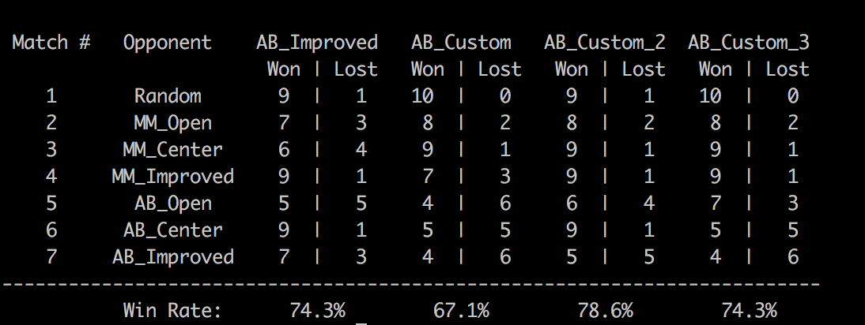

The best performing heuristic evaluation function was Heuristic 2 78.6% of win rate, and therefore it is recommended to be used and submitted in ‘custom_score()’.

Three reasons justifying the recommendations are:

* It is a perfect balance of less computational cost and consideration of giving rewards as well as punishment for a wrong move.
* The Heuristic 1 considers only the moves left for our game agent, ignoring the punishment for number of moves left for the opponent. Hence Heuristic 2 is better than Heuristic 1.
* The Heuristic 3 considers one more parameter, that is, distance of both opponent and the game agent from the center of the board. The calculation of this distance causes more computational cost, hence reducing the depth traversed in the game. Therefore Heuristic 2 is better than Heuristic 3.
* From the above performance we can see that Heuristic 2 is very consistent in winning as compared to the other heuristics where it is loosing atleast once.